Title of the Event | Technical Talk on Investment Banking Operation | 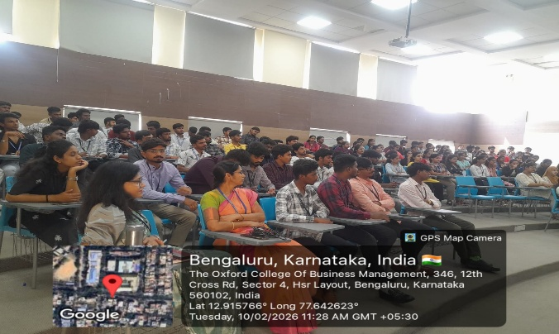
Day and Date | 10 February 2026
Venue (With all details ) | Room No-407
In collaboration with ( if any) | -
Details of Resource Person With Designation | Mr.Maheshwar Narayanan,  IMARTICUS | 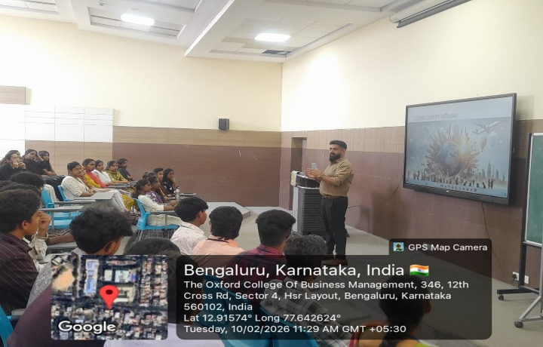
Organizing Department/Coordinators | Business Mnagement/  Dr.Praveen Kumar Sinha
Course and semester | MBA I and III Sem
No of Students & Faculty Participants | 100

Coordinator HOD Vice-Principal Principal

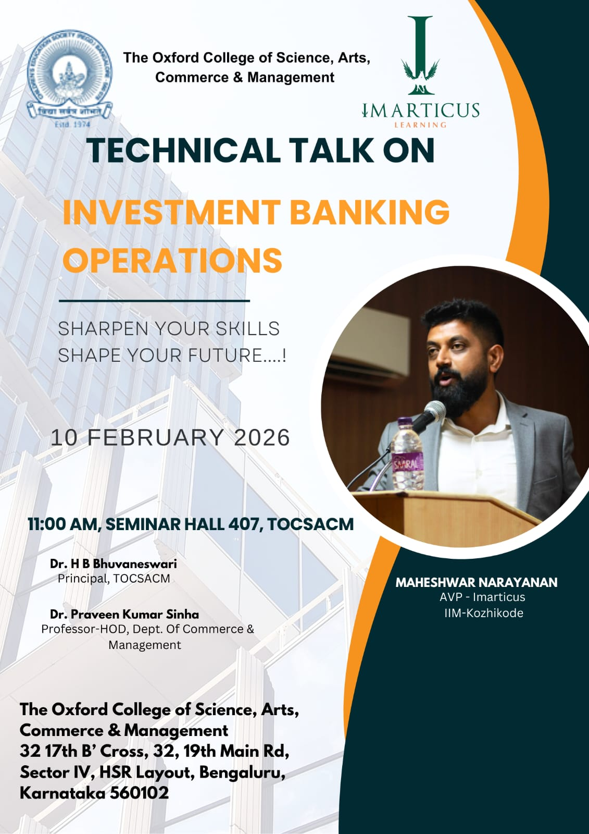

On 10-02-2026, Tuesday, The Oxford College of Business Management organized a highly informative for Technical Talk on Investment banking operation for MBA students to enhance their understanding of the field of finance and investment. The workshop was designed to provide students with a comprehensive overview of key concepts related to investment management, including financial markets, investment strategies, portfolio management, and risk mitigation. Industry experts and finance professionals led the session, offering valuable insights into various investment instruments, including stocks, bonds, mutual funds, and derivatives. Key topics covered included investment strategies such as value and growth investing, as well as techniques for managing risk through diversification and hedging.
Additionally, the workshop provided an in-depth look at portfolio management, focusing on asset allocation, rebalancing, and evaluating performance. Ethical considerations and the regulatory framework governing investment practices were also discussed, emphasizing the importance of transparency and responsible investing. Through interactive case studies and group exercises, students were able to apply the concepts learned and engage in real-world investment decision-making. The session concluded with a Q&A segment, where students had the opportunity to deepen their knowledge by interacting directly with the experts.
At the conclusion of the workshop, all participants were awarded certificates of participation in recognition of their involvement and learning. The workshop successfully met its objective of equipping MBA students with the knowledge and practical insights necessary for careers in investment management, finance, and portfolio management.

